The Korona Killer

Adonis FernandezRunner, Matthew Salagubang, Zarif Shahid, Jaezreel Quiliza, Andrew Stites

Introduction to Engineering || Assignment 3

Professor Praveen Meduri

22 October 2020

Abstract

Ever since the outbreak of the corona virus happened in the end of 2019, the world has been in shambles. Millions of people all over the world have lost their lives and loved ones. It’s caused hospitals to get overcrowded and doctors and nurses to get overwhelmed. Not only the USA, but the entire world was on shut down for months on end. People lost their jobs, the stock market temporarily crashed and even something as necessary as going to the grocery store to get food for your family was looked down. Finally after almost a year of the country being closed down, things are starting to open back up. The worst thing that could happen to the world right now is the cases to go back up as more and more public places are opening up. So what our team will attempt is to make a device that takes sanitation to the next level. So that when people enter a public place, they kill all germs, ensuring the safety of everyone present at the respective locations they visit. We call this invention The Korona Killer. The Korona Killer will be the first product the consumers interact with when they enter a public establishment.

Introduction

  Before Corona, life was very easy-going in terms of forms of contact with one another and daily tasks to do. We were all able to freely eat, shop, and sit in crowded places. However, covid-19 had different plans for the entire world. Introducing a new pandemic that swept everyone off their feet. It wasn’t treated seriously at first due to the lack of swiftness our country has demonstrated; thus leaving our entire country into a panic and eventual quarantine and stricter safety guidelines. We have endured almost a year with Corona hitting California alone on January 26th and instituting a lockdown on March 4th. Seven long months and we are still stuck with social distancing and quarantine, but now The Korona Killer is here. The Korona Killer: our patented invention that will take sanitation and cleanliness to the next level. Our product will work in various ways to prevent, stop, and kill Covid-19. The Korona Killer is a sanitation station that is a multi-tool of sorts. It is able to sanitize any items on a person such as: keys, wallets, phones, etc. Along with this, our machine would have the capability of reading temperatures both internal and external. Accompanied with a UV light that kills the germs on the exterior. Hand sanitizer and gels will eventually become too costly and as well as less inefficient as time goes on. If we keep sticking to the same methods, this virus will continue to evolve, rendering our subliminal tactics useless. However, this is where The Korona Killer comes to light. Utilizing our patented UV conveyor belt, we can blast UV light on everyone’s traveling accessories. This will ensure viral safety along with our extensive temperature and sanitation stations for the people. Allowing change means allowing effective treatment for us as well. Once we are able to take the necessary steps and eradicate the virus rather than doing the bare minimum, we will all be able to return to our normal lives.

Problem Statement

From the outbreak of the recent disease found in Wuhan, China, many people’s lives have been affected. The virus first was discovered in December of 2019 and scientists have been battling with the cause from which it originated ever since [1]. Due to the newly found form of the disease, COVID-19, humans have yet to answer for the disruptions that have caused many to end up changing their daily lives. Coronaviruses have been around in its natural form for many years, from first being characterized in the 1960s [2], the 2019 virus discovered has been a new form of the disease that has been recently discovered which belongs to the same family that has first characterized similarly with the 1960’s family. The effects of the coronavirus target the respiratory tracts of humans causing severe cold symptoms. Though the disease is more prone to being affected by those that have weak immune systems, newly found COVID-19, the 1960s virus was more commonly found in children, yet there are possibilities that the infection can occur to anyone at any age. In the United States, the occurrence of the virus causing large epidemics was stated to have intervals of 2 to 3 years. Over time, the virus has been able to evolve into new forms following its strength in 2019.

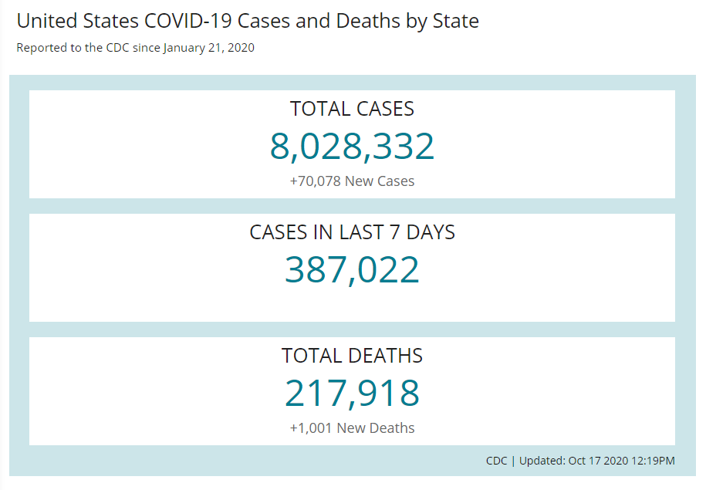

The United States Centers for Disease Control and Prevention, CDC, has been monitoring the rise of COVID-19 cases throughout the country. With the total death count rising to 217,918 people since January 21, 2020, the numbers are expected to rise along with the total case count of 8,028,332 confirmed cases in the nation [3]. The expected numbers have been rising ever since the breakout in the early days of 2020 and are expected to rise to even greater heights due to the upcoming flu season. The expectancy due to previous outbreaks of diseases tend to follow a greater trend during the cold months of the year, COVID-19 has been expected to rise along with the influenza trends. From previous years, these contagious flu-like symptoms that target the respiratory of humans have peaked from the middle of the December month to the middle of January [4].

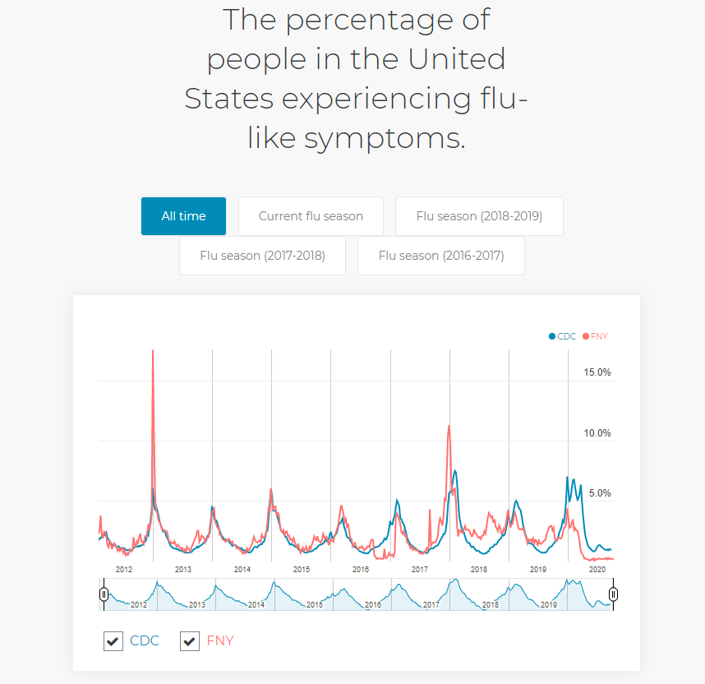

Symptoms of the COVID-19 outbreak have been listed by the United States Centers for Disease Control and Prevention. The symptoms are said to last from a period between the days 2-14 after a person has been exposed to someone that contains the virus. As listed [5], “the symptoms are fever or chills, cough, shortness of breath or difficulty breathing, fatigue, muscle or body aches, headache, the new loss of taste or smell, sore throat, congestion or runny nose, nausea or vomiting, and diarrhea”. To seek medical attention is only advised [5] when the symptoms are presented as follows, “trouble breathing, persistent pain or pressure in the chest, new confusion, inability to wake or stay awake, bluish lips, or face”. Due to rising numbers of cases, the limited supply of medical attention is only available to those that have serious symptoms, otherwise, the information as follows, keep a distance between others and stay home.

The CDC has informed the public [6] the best way to prevent the spread of COVID-19 is to avoid being exposed to the virus. With the spread mainly caused by a person to person interaction, the prevention of exposure can decrease the likelihood a person can obtain the undesired virus. The main causes of person to person interactions as follows [6], “between people who are in close contact with one another (within about 6 feet), through respiratory droplets produced when an infected person coughs, sneezes or talks, droplets can land in the mouths or noses of people who are nearby or possibly be inhaled into the lungs, and recent studies have suggested that  COVID-19 may be spread by people who are not showing symptoms.” The CDC has also listed information for the public to limit the chances of obtaining the disease by following cleanliness guidelines [6]. The cleanliness guidelines as follows, washing hands as often as possible, avoiding close contacts with others both inside and outside of homes, through the covering of the mouth and nose with a mask when exposed to others, covering all coughs and sneezes, make disinfecting a priority, and monitor your health daily.

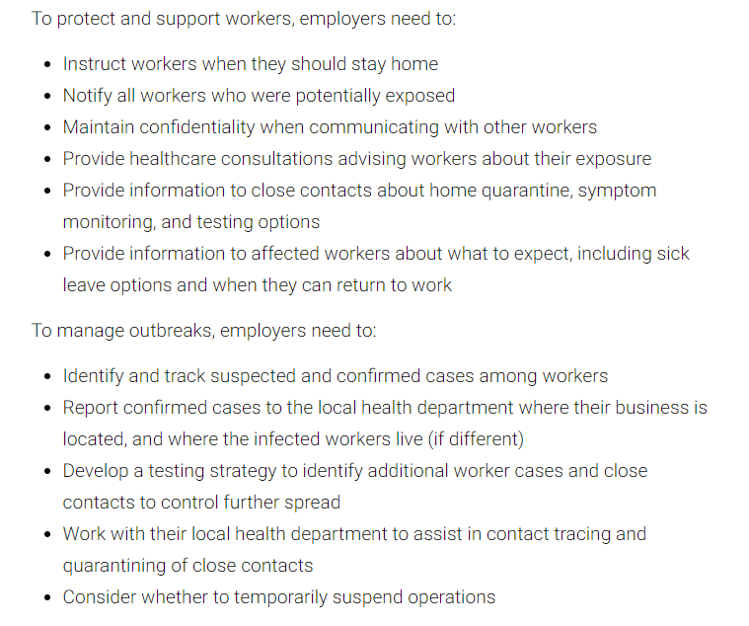

The limitation that businesses have been advised to prevent the interaction of people in their environment has been provided. The livelihoods of people have been taken into consideration due to the outbreak of COVID-19, people still have the eligibility to enable themselves to work around the precautions advised to prevent the spread of the virus itself. Businesses have been advised to follow precautions as listed to protect and support their workers [7]. Businesses also have been given precautions to follow to prevent the spread of the virus [7]. When the precautions are taken into action, the ability to control the spread of COVID-19 has been successful. By applying the guidelines and followed by the public, the results have been provided that the peak of the outbreak has been delayed to a later date [8]. The reduction since the application of the guidelines has been able to be reduced by 23 percent in the general population.

Product Design

Our product we envisioned would resemble a metallic arch with a high-powered infrared thermometer implemented at the bottom of the apex perpendicular to the ground. Connected to the right of it would be a UV lit conveyor belt to take in any accessories that the individual may possess. On either side of the arch, usually the side with the UV conveyor belt, it would possess a “no touch” hand sanitizing spout. This spout would utilize the mechanics for a foot water pump as to save on electricity usage. In the legs of the arch, there will be a small compartment to house a bag for hand sanitizing solutions. This will be dependent on where the spout is set up. The foot pedal will be attached to a pump causing a negative pressure gradient and allowing for hand sanitizing solution to be pumped out. This overall design would be modular entailing the construction would be fitting for any business or facility. This will allow for accessibility for all and easy, reasonable, implementation. The overall arch would be 8 feet tall at its highest point as to accommodate for any individual and 3.5 feet wide. Two signs will be posted: one on either of the sides of the arch stating to position your head looking upward once you step under the infrared thermometer and next to the infrared thermometer conveying the spot to settle your eyes on. The infrared thermometer will calculate the temperature by utilizing black body radiation and transmit that information to a low-energy screen only displaying temperature and either acceptance or denial of entry. A horn will sound if, and only if, someone has been deemed too hot. This will allow for the public and self-awareness to leave the store immediately to get checked by a medical professional. The conveyor belt will be foot operated also with a sliding mechanism at the bottom of the conveyor belt maneuvering a tray in a one-directional fashion. The tray will hold all accessories and be able to slide seamlessly and easily with the individual’s foot through a small opening of “plexiglass” into the UV chamber to undergo sanitation and out in a similar fashion. The modulation would allow for the UV conveyor belt to be constructed after the temperature reading and sanitation of the hands. This will also allow for a separation of parts so that flexibility and versatility is at the utmost of our product. Any facility can have the Korona Killer, for instance, with the arch in the initial entrance and the UV conveyor belt after patrons have acquired their cart. This will allow for a streamlined experience minimizing frustration and time attempting to just get into the store.

Our product would be ideal for customers and business employees due to the easy of use and non-technical troubleshooting if a problem were to occur. The initial cost would be offset due to the payroll saved from an employee not having to be present when customers proceed into the business. In addition to, the low energy usage will not drastically change the overall KWh used by the business. Customers will feel safer knowing the company cares about health and are striving for a clean environment. Having this feeling, the company will have more patrons coming to shop without any fear of contracting the virus. This will be a great addition to any company considering the winter season approaching fast and hard. The infrared thermometer used will be of a slightly higher caliber compared to hand infrared thermometers due to the distance the customer may be from the arch’s apex. According to the U.S. Food and Drug Administration, the benefits of using an infrared thermometer will reduce the risk of transfer from the person being evaluated, reads temperatures quickly and accurately, and its easy to clean[9]. Having this in our Korona Killer will gives us a competitive edge compared to other products of somewhat similar standings. Thankfully, our Korona Killer will not have a visible light being emitted from the infrared thermometer as to not cause any afflictions to persons with, for instance, epilepsy, migraines, or even eye damage for that matter. The UV Chamber will be housed, concealing it from any customer and/or employee as to not expose any individual to the rays unnecessarily. This chamber will have draping rubber strips behind the “plexiglass” exterior to allow for the one-dimensional tray to move freely in and out of the concealment for a simple sanitation of accessories. These strips will block all UV light from escaping once the trigger has been hit by the foot pedal as the customer moves the tray. This trigger will be in place as another route to save on energy usage and to be a cost-effective product in addition to. It will be stationed in the middle of the UV light chamber to be initiated as soon as the one-dimensional tray locks into our patented holding mechanism that utilizes a small amount of energy to run a quick timer for proper sanitation. This will ensure a clean entry will minimal transmissions between anybody anywhere.

Conclusion

Ultimately, The Korona Killer could potentially lower the cases of COVID-19 from the workplace, everyday life, and fun activities. As stated, The Korona Killer is an easy to use tool with many handy gadgets to ensure everyone’s health is accounted for. Having this product in the economy could bring back everyday life. It would give people reassurance in public places. In the workplace, workers would feel more protected knowing that their company cares about their health and the safety of everyone. Society should take this product and utilize it. At this stage in life, it is extremely hard for everyone to return to their usual everyday life, hopefully this product could do it for all entrusted in it.

References

1. “About COVID-19,” *Centers for Disease Control and Prevention*, 01-Sep-2020. [Online]. Available: https://www.cdc.gov/coronavirus/2019-ncov/cdcresponse/about-COVID-19.html. [Accessed: 20-Oct-2020].
2. J. S. Kahn, “History and Recent Advances in Coronavirus Discovery : The Pediatric Infectious Disease Journal,” *LWW*, Nov-2005. [Online]. Available: https://journals.lww.com/pidj/fulltext/2005/11001/history_and_recent_advances_in_coronavirus.12.aspx. [Accessed: 20-Oct-2020].
3. “CDC COVID Data Tracker,” *Centers for Disease Control and Prevention*, 19-Oct-2020. [Online]. Available: https://covid.cdc.gov/covid-data-tracker/.

[Accessed: 20-Oct-2020].

1. “The percentage of people in the United States experiencing flu-like symptoms.,” *Flu Trends: Estimate of percentage of people with flu like symptoms*. [Online]. Available: https://healthmap.org/flutrends/. [Accessed: 20-Oct-2020].
2. “Symptoms of Coronavirus,” *Centers for Disease Control and Prevention*, 13-May-2020. [Online]. Available: https://www.cdc.gov/coronavirus/2019-ncov/symptoms-testing/symptoms.html. [Accessed: 20-Oct-2020].
3. “How to Protect Yourself & Others,” *Centers for Disease Control and Prevention*, 11-Sep-2020. [Online]. Available: https://www.cdc.gov/coronavirus/2019-ncov/prevent-getting-sick/prevention.html. [Accessed: 20-Oct-2020].

[7] S. of California, “Industry guidance to reduce risk,” *Coronavirus COVID-19 Response*, 19-Oct-2020. [Online]. Available:

https://covid19.ca.gov/industry-guidance/. [Accessed: 20-Oct-2020].

[8] F. Ahmed, N. Zviedrite, and A. Uzicanin, “Effectiveness of workplace social distancing measures in reducing influenza transmission: a systematic review,” *BMC public health*, 18-Apr-2018. [Online]. Available: https://www.ncbi.nlm.nih.gov/pmc/articles/PMC5907354/. [Accessed: 20-Oct-2020].

[9]Center for Devices and Radiological Health, FDA Medical Editors. “Non-Contact

Infrared Thermometers.” *U.S. Food and Drug Administration*, FDA, 2020,

[www.fda.gov/medical-devices/general-hospital-devices-and-supplies/non-contact-infrared-](http://www.fda.gov/medical-devices/general-hospital-devices-and-supplies/non-contact-infrared-thermometers.)

[thermometers.](http://www.fda.gov/medical-devices/general-hospital-devices-and-supplies/non-contact-infrared-thermometers.)

[Accessed: 20-Oct-2020].